A Customized e-Shopping System for SMEs in Developing Countries

E. A. Olajubu¹ ,S. B. Afolabi² and A. O Ajayi³

Obafemi Awolowo University
Department of Computer Science and Engineering
¹emmolajubu@oauife.edu.ng, ²bafox.oauife.edu.ng and ³aunajayi@oauife.edu.ng

Abstract

Electronic shopping-the business-to-customers dimension of electronic commerce is a system that enables a user to purchase one or more commodities by way of a network such as the Internet and it provides for customization of products and services, in contract to buying in a store or ordering from a television advert, which is usually limited to standard products. This has initiated a global competition among goods and services delivery around the globe, unfortunately lack of communication infrastructure has put the Small and Medium scale Enterprises (SMEs) in developing at a serious disadvantage. Therefore, this paper proposes an e-shopping system for SMEs in developing countries as a means of participating in the competitive global market for goods and services. Various issues affecting the development and implementation of e-shopping for developing nations’ business were identified. Solutions to these shortcomings were also proposed and easy way of developing e-shopping for developing nations’ SMEs is presented. A model that signified the digital divide between multi-national and SMEs in developing nations is presented.

Keywords: SMEs, ICT, Market Structure, Internet, Infrastructure, e-commerce.
1.0 Introduction
Electronic shopping - the business-to-customers dimension of electronic commerce which can be defined as a system that enables a user to purchase one or more commodities through computer network such as the Internet and it provides for customisation of products and services, in contrast to buying in a store or ordering from a television advert, which is usually limited to standard products [6]. E-commerce has removed distance barrier, thereby increasing global completion among goods and service providers. While the multinationals have the advantage of large scale production and better funding, they posses the wherewithal to secure ICT equipment that will project and promote the sales of their products beyond the border of their nation even throughout the world using the World Wide Web. This has allowed the infiltration of goods and services provided from advance economies into many developing nations’ economies. While it is advantageous in terms of quality of products, it is to the detriment of the SMEs in these nations. The SMEs which dominates emerging nations’ economies do not have a global competitive advantage in the world market, since they cannot fund the facility required to project their goods and services through the World Wide Web, their goods and services terminates at the boarders of their native nations. This peculiar problem does not allow the SMEs in developing nations to contribute significantly to economic development of their nations as oppose to the SMEs in developed economies. Due to lack of involvement in global competitiveness, SMEs in developing nations does not have good attitudes to research and development and therefore lacks innovative drives. It is very difficult to find researches sponsored by “large” SEMs, this is due to little or no challenge for improvement in goods and services delivery. Consequently, SMEs in developing countries have remained in their traditional way of goods and services provisioning and delivery which has not encourage economic growth nor foster realistic national development. It is also regrettable that the political powers in developing nations especially sub-Sahara desert of Africa does not have any initiatives for their SMEs, unlike the developed economies where SMEs activities have been used to encouragement employment, reduced poverty and have contributed immensely to national development and their products internationalized [9]. There are merad of problems militating against developing nations’ entrance into electronic super highway. Many of this problems are highlighted in [14] Therefore, there is no reasonable growth in the sector, that is why it difficult having multinationals arising from developing countries. Multinational companies always come from developed nations where scientific research has contributes significantly to the process of goods and services provisioning and delivery. In attempt to expose SMEs in developing nations to global market competition, drives for scientific research and possibly borrow idea from their counterpart abroad, this paper proposes an e-commerce framework for SMEs in developing nations as a tool for economic leverage so as to become relevant in the global competitive market. It provides an alternative ways for e-payment, when facility such as credit cards is not available thereby allowing people without advance technology to make use of e-shopping. The rest of the paper is organized as follows: section two defines SMEs in developing countries context and also discusses the market audience structure; section three elucidates the peculiar problems facing SMEs which do not allow ICT infrastructure usage; section four presents the model architecture and peculiar solution to the problem of e-commerce adoptions by the SMEs; section five states users requirements and some screen shot of the system developed while section six gives the conclusion.

2.0 Small and Medium Scale Enterprises
According to [7] SMEs is defined as a very heterogeneous group of businesses usually operating in the service, trade, manufacturing and agro-allied sectors. They include a wide variety of firms such as village handicraft makers, small machine shops, and computer software firms that possess a wide range of sophistication and skills. Some are dynamic, innovative, and growth-oriented while others are satisfied to remain small and perhaps family owned. SMEs usually operate in the formal sector of the economy and employs mainly low-wage-earning workers. While e-commerce is seen as a strong tool that can reduce transaction cost of international market [10] [12] to a low level where developing nations can actively participate, it is disheartened that economic reasons have not allow many SMEs in developing countries to respond positively to Information and Telecommunication Technology (ICT) adoption [7][11]. They lack effective organisation and knowledge of modern technologies such as electronic commerce. The major challenge facing SMEs in their utilisation of e-shopping facilities have been the issue of payment, mostly due to the high cost and unavailability of e-procurement facilities such as credit cards.
SMEs are often classified by the number of employees and/or by the value of their assets. The size classification varies within regions and across countries relative to the size of the economy and its endowments. It is important to note that there is a minimum as well as a maximum size for SMEs. For instance in the USA, the small business administration defines ‘small business’ as any business with less than 500 employees. The latter figure may represent medium to large enterprises in the African context [7]. SMEs which are often household enterprise form the major basis for employment in any economy especially the developing economy [1]. This important segment of economy has been neglected thus far in the deployment of Information and Technology Communication (ICT) in many development countries especially Africa where entrepreneurships development is far becoming the sine qua non of economic growth [2]. The impact of ICT on both SMEs and multi-national companies in the developed world is immense. Business methodologies and strategies have greatly been influenced in the developed economy in such a way that you can order your goods from your house or office and have them delivered at your door step within a few minutes at little or no cost. This improved business strategy [13] is very rare in developing countries. Where available, it is owned by the multi-nationals from the developed worlds that have the wherewithal to meet and use the modern “business kwon-how” of today which is the Electronic Commerce (EC).
EC is an emerging concept that describes the process of buying and selling or exchanging of products, services, and information via computer networks including the Internet. [2] define EC from these perspectives:

- From a communications perspective, EC is the delivery of information, products/services, or payments over telephone lines, computer networks, or any other electronic means.
- From a business process perspective, EC is the application of technology toward the automation of business transactions and workflow.
- From a service perspective, EC is a tool that addresses the desire of firms, consumers, and management to cut service costs while improving the quality of goods and increasing the speed of service/delivery.
- From an online perspective, EC provides the capability of buying and selling products and information on the Internet and other online services.

  - Market structures
The origin of commerce by exchanging goods occurred before recorded history, now commerce is a basic activity of goods trading and buying in everyday life. Entering into the electronic era, the way individuals and organizations do business and undertake commercial transactions have been changed. This indicates the movement towards electronic commerce. This means there is no paper work and physical interaction is limited, if at all. The emergence of electronic commerce started in the early 1970s with the earliest example electronic funds transfer (EFT), which allows organizations to transfer funds between one another electronically. Then another technology electronic data interchange I) was introduced. It helps to extend inter-business transactions from financial institutions to other types of business and also provides transactions and information exchanges from suppliers to the end customers. However, the early system development was limited to special networks such as large corporations and financial institutions, which are costly and complex to administer for small business. So EDI was not widely accepted as expected [8].
With the progress of Internet technology and a highly developed global Internet community, a strong foundation of prosperous electronic commerce continues to be built. During the 1990s, the Internet was opened for commercial use; it was also the period that users started to participate in World Wide Web (WWW), and the phenomenon of rapid personal computer (PCs) usage growth. Due to the rapid expansion of the WWW network; e-commerce software; and the peer business competitions, large number of dot-coms and Internet starts-ups appeared. Integrated with the commercialization of the Internet, Web invention, and PC networks these three important factors made electronic commerce possible and successful [5][8].

2.2 Market Structure Model
It is a good marketing practice to always compare the effectiveness of the implementation/production of goods and services with that of others to know where one is of a comparative advantage. Therefore, if a good or service cost more but brings in better sales than other alternatives, emphasis should be placed on this particular good or service.
Figure 1 is the model we have developed to compare the effectiveness of cost against reached audience in a marketing environment. In this model, it can be observed of that
Ratio of effectiveness = Cost of implementation / Reached Audience

This means
BC / AC for Oral Advertisement
DE / AE for radio-vision
FG /AG for Internet
It can be observed that
BC/AC = tan α
While
DE/AE = tan ρ
and
FG/AG = tan µ

By observation
tan α > tan ρ > tan µ

This implies that there is an increase in effectiveness as you move from oral advertisement to Internet advertisement due to the number of audience reached.

Reached audience
Cost of Implementation
Oral
Radio-Vision
Print media
GSM
Internet
ρ
μ
A
B
C
α
D
E
F
G

Figure 1: A model for comparing the effectiveness of cost against reached audience
The gap between the Internet advertisement and the Oral advertisement or better Radio-Vision advertisement in terms of audience reached in Figure 1 signifies the gap between the SMEs in developing nations and the multinationals in these nations in terms of market sharing. The Internet serves as a levelling ground for both multi nationals and SMEs in developing countries, if the SMEs can pull resources together so as to get access to the Internet for their marketing. Therefore, it would be an advantage for SMEs to be able to avail themselves of the offer of Internet. The major problem for these SMEs is the initial capital outlay required for Internet infrastructures and implementation. This is the reason for this discuss.

- E-shops and developing countries
An average e-shop that is making waves in developed world may not function with the same aplomb in developing countries. This is due to some peculiarities that can be found in these developing countries. It is a well known fact that a technology that succeeded in one country may not in another. An example is Minitel that worked so well and was so popular that it became an instance success in France which did not quite succeed in some other countries. In most developing countries especially in Africa, there is a number of intimidating problems availability of infrastructures to bandwidth problems and on to even logistics problems.
As one would have noticed, small and medium scale enterprises vary in sizes and capacities from country to country. In most developing nations, majority of these enterprises are made up of just one employee (the owner who gets help once in a while from a member of the family. This is to say that if such a person gets to be able to put his wares on the net (on a e-shop), it will come as a big relief to him as attending to individual clients who has come to the shop would no longer be a problem. Such a person could gain enough time to get into other projects. Some of the problems that confront the setting up of an e-shop in developing countries that we encounter in course of this study includes but not limited to:

  - Lack of national or initial infrastructure
Our country of study is Nigeria, and the first basic thing we encountered was the absence of basic infrastructure like telephone lines (ADSL lines, Vsat, Fibre cables etc.) that could allow each would be e-buyers and e-sellers access to the e-shop where the two of them can meet for the purpose of exchange of goods and services. At first, this did not make the venture an interesting adventure to take as there is no guarantee that the e-buyers may ever get to see and appreciate the goods on offer. To this effect, the prospects of developing the site became uninspiring.
Eventually, an advert by a GSM operator that it gets up to a million hits per day changed the whole story. It is now a question of making the site as popular as possible in order to get people to start logging on to it.

  - Initial cost of putting up such sites
As earlier highlighted, the notion of SMEs in developing countries cannot be compared to that of developed nations. The turnover of most SMEs in Developing countries is barely able to pay for hired hands. In fact, most of the SMEs are also seen as family businesses where the business is overseen by a member of the family (and this usually is for free that is none paid). So in essence, any extra cost that may come into the business is avoided as much as possible. The initial cost of buying the equipment and other necessary things to get the market started might become prohibitive for the economy of such an SME.

  - Logistics and distribution
Distribution of mails or regular posts is one of the most challenging problems in developing countries. There are so many reasons for these: indiscriminate buildings that make addressing difficult, irregularities in the functioning of local postal services that make delivery to take longer than necessary, transportation problems (e.g. bad roads, inadequate transports, etc.).

  - Payment methods
Until recently, most developing nations do not use any other payment facility than cash. The number of residents having access to credit or debit cards was limited and as such the possibility of Internet payments was therefore limited to these privileged few. Therefore, in order that other people may have access to these types of shops other means of payment must be explored.

  - Lack of trust
In Nigeria in particular, there is a major problem of trust among the citizenry. This is a major problem as a minimum level of trust must be displayed between participants of the market place. A buyer must have a certain amount of trust that the seller is selling is what he claimed to be selling and the seller must believe that the buyer is giving the right information about himself.

- Basic Web Process Model
According to [4], the most basic process model used in web site development should be familiar to most people, as it is deductive. The basic model starts with the big picture and narrows down to the specific steps necessary to complete the site. In software engineering, this model is often called the software lifecycle model, because it describes the phases in the lifetime of software. For a trade to occur between a buyer and seller, a certain process must occur. Figure 2 is the architecture for this work which illustrates the basic processes involved in e-shopping between a buyer and seller.
A customised electronic shopping system consists of five major services: an e-buyer agent, an e-shop for made-to-specification goods, suppliers that stock/manufacture goods to be sold through the e-shop, shipping agency that ships the ordered goods to the e-buyer and a payment validation service. From the architectural model, the buyer logs on the marketplace, through the Universal Resource Locator (URL) of the website, the buyer then searches for product, when the product have been found, the buyer selects product using the shopping cart, the e-buyer sends details of its requirements for a particular product to the e-shop. The e-shop provides a list of suppliers that can possibly meet those requirements and for which it works as a price - negotiating agent. The e-buyer forwards the product specification to the chosen supplier(s), who confirm if it is possible to supply the product. The suppliers forward the costing of the order to the e-shop. The e-buyer negotiates the price with the e-shop and places the order. The supplier contacts a shipping agency about delivering the order. The shipping agency replies with the pickup date. Finally the shipping agency informs the e-shop and the e-buyer about the delivery date. The e-buyer sends a confirmation on receiving the placed order. Since the goods are made-to-specification, cancellation of an order is allowed only within 24 hours of placing the order.

  - Steps in Electronic Shopping Systems
The following steps itemised below illustrates the processes involved in an electronic shopping systems. The e-buyer logs on to the electronic marketplace through several means such as locating the site through an Internet search engine like Google.com, Find.com, and Yahoo.com or by using the Universal Resource Locator (URL) of the e-shopping site e.g. www.buynow.com. When the e-buyer is logged on to the e-shopping website, he searches for products by using available category hyperlinks. Some e-shopping sites also have a search engine facility that enables e-buyers to search for specific products.
When the e-buyer is satisfied with a particular product, he selects the product into an electronic shopping cart, which is similar to the conventional cart or trolley used in departmental stores. The e-buyer specifies that the products that have been selected into the shopping cart be sent to the e-shop for processing. The e-buyer forwards the product specification to the chosen supplier(s), who confirms if it is possible to supply the product. The e-shop confirms that the order has been received from the e-buyer and confirms if the products ordered are available from the manufacturer. The supplier forwards the costing of the order to the e-shop. The e-buyer negotiates the price with the e-shop and places the order. The e-buyer makes his orders by using electronic procurement facilities like credit cards and debit cards. The procurement information supplied by the e-buyer is sent to a Transaction Handlers Bank (Automated Clearing House) that validates the information supplied by the e-buyer. The Transaction Handlers Bank checks credit card or debit card information for authentication. If the credit information is authentic, then the Transaction Handlers Bank sends a confirmation to the e-shop that the credit has been approved. The e-shop then commences the processing of the order, by sending the e-buyer’s transaction details to the supplier. The supplier contacts a shipping agency about delivering the order. The shipping agency replies with the pickup date.

  - Steps taken to correct peculiar problems
Some of the problems with developing countries highlighted above are so peculiar with developing countries that they need to be solved locally or a means of contouring the problem. These problems are either solved or avoided. Some of the problems earlier highlighted are taken care of by using any of the following:

- Infrastructural problems are taken care of by hosting the sites outside of the country (i.e. in developed countries). The uploading of the sites could be done from a cyber café as well as the negotiations.
- Hosting of these sites outside of the country may become expensive due to exchange rate and other reasons. In order to take care of this problem, a number of SMEs can be grouped together on a site so that this cost is spread and borne by all. Another SME could be created to cater for the hosting and the general well being of the site.
- Distribution and logistic can be taken care of by creation of collection points. This avoids the delays experienced through the use of postal services that are comatose. Collection points are created in each of the major centres/towns. The goods for each individual customer are delivered based on the nearest collection point possible. There can be many collection points in each town depending on the number of customers to that town and depending on the buying frequency of that town.
Product received
HOME PAGE

CONTENT SERVER
Buyer searches for product
In some systems, sellers can update their own product information. In others, a central administrator does that job. Some systems also list advertising, news and specials.
CATALOGS

DYNAMIC PUBLISHINGSERVER
Content can be generated dynamically based on user profile.
Buyer selects product
PURCHASE ORDER

TRANSACTION PROCESSING
Buyer orders product
Purchase order sent to seller
LEGACY INTEGRATION
SELLER LEGACY SYSTEMS
ORDER INFORMATION
USER PROFILE USER PREFERENCING SYSTEM
Seller confirms order
PAYMENT OPTIONS
TRANSACTION PROCESSING
Buyers pays for product
Payment information sent to bank
LEGACY INTEGRATION
BANK
BUYER’S BANK
Credit checked
SELLER’S BANK
Product shipped
Credit approved

- Buyer logs on to the marketplace

Figure 2: e-shopping Architecture

- Until recently no debit or credit cards existed in Nigeria or most of the developing countries. So the methods of payments became an issue. With the arrival of debit cards, this problem was reduced but with that there are still quite a number of people who do not have access to these debit cards. For these categories of people we suggested the use of telephone recharge cards. Since every nook and cranny of Nigeria is now pervaded with phones cards, the buyer can buy a telephone recharge card of equivalent value as the price of the goods he is buying. These credits (recharge cards) can be sent to the seller and his (buyer’s) goods can then be sent to the collection point nearest to him.
- The reputation of the individuals hosting the site can serve as a means of avoiding such a problem.

5.0 Requirements

Due also to some specific problems encountered in developing countries, for instance, in terms of the bandwidth available unto them the system should be such that can load as fast as possible with a reduction in the number of images used. We have also reduced the quality of the images used. This was done in such a way as not to impair too much on the quality of the image but was done to reduce the resolution of the image which reduces the size and consequently reduced its download time considerably.
Accesses to the Internet have greatly increased with the proliferation of Cyber cafés that are now available in numbers in major cities. This also comes with its attendant problem of cyber crimes. In order to aid the crime fighters as much as possible, the system tracks the IP addresses of the machines that are connected to it from which ever location. Also for now, credit or debit cards are IP address attached. This is also a cyber crime combating measure. Although this is known to be limiting and inefficient, alternative measures are being explored actually to try reduce frauds on this site.

5.1 End User Requirements

The end user would require to use the application from any web browser supporting HTML 3.2 (or later standard) and cookies, this is due to some of the security features built in it. It is also necessary to uniquely identify each user; therefore each user must necessarily register to be able to use the system. Each user registration is therefore a property of the user and he/she takes responsibilities for whatever that username is used for on the site.
Security of sensitive information (like scratch card number etc.) is of paramount importance, so is the site built on SSL. The issues involved in this are left out of this write-up. Users are able to search the entire database based on category or based on each item or based on a keyword. They can change items, quantities, etc. They can also view the status of their order.

5.2 End User Interaction with the Shopping Cart Application
This is a sequence of actions carried out by typical users, who visit the web site for shopping. New users coming to the site for the first time register themselves. Existing users authenticate themselves by providing a user-id and password. After authentication is successful, the users, having browsed the product titles, add the items to their cart. Then, they view the list of items in their cart. The user might want to change the quantities of the items or delete items selected earlier. After the user is sure that he wants to buy all the items in his cart, the user checks out. Checking out is the confirmation from the user that he wants to buy all the items in his cart. After the user has checked out, all the items in the user's cart are entered in the database, and these items are later shipped to the address of the user, given at the time of registration. After checking out, the user can continue shopping or can decide to logout. Users can also just browse the music and book titles available in the shopping cart site, without purchasing any items. Sometimes users would be interested in viewing the current status of their account, and the status of items, (e.g. whether they have been shipped or not), purchased by them earlier.
Some of the screen shot of the software are provided below.

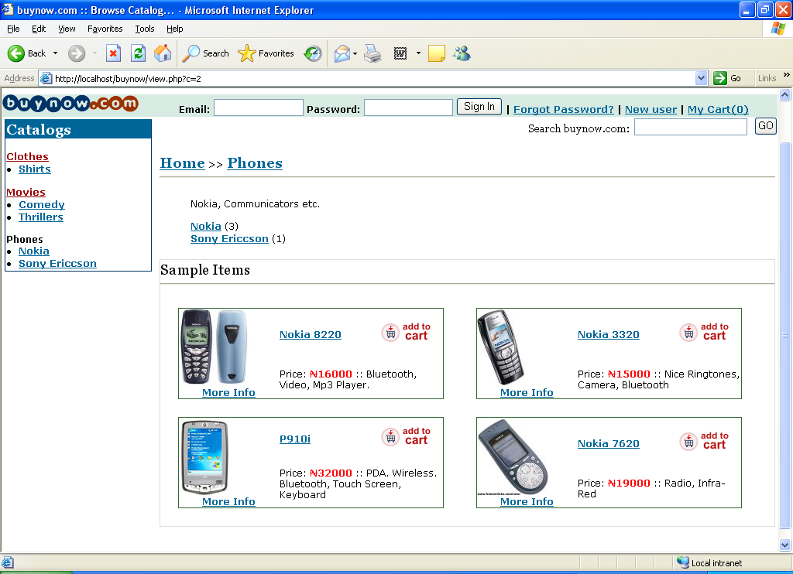
Home Page Screen Shot Sample Items in Shopping Cart
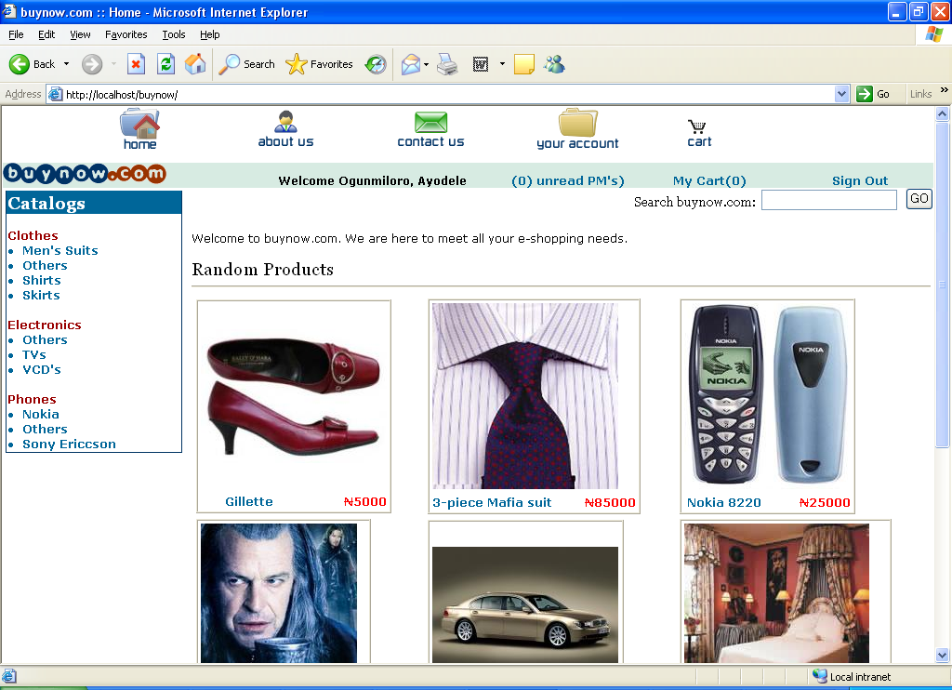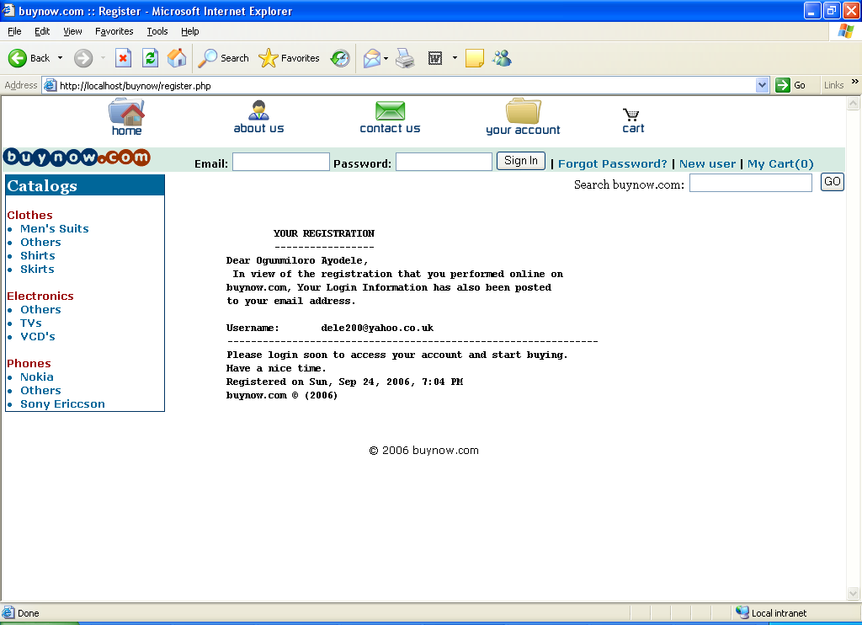
Shopping Items display Registration Response Page

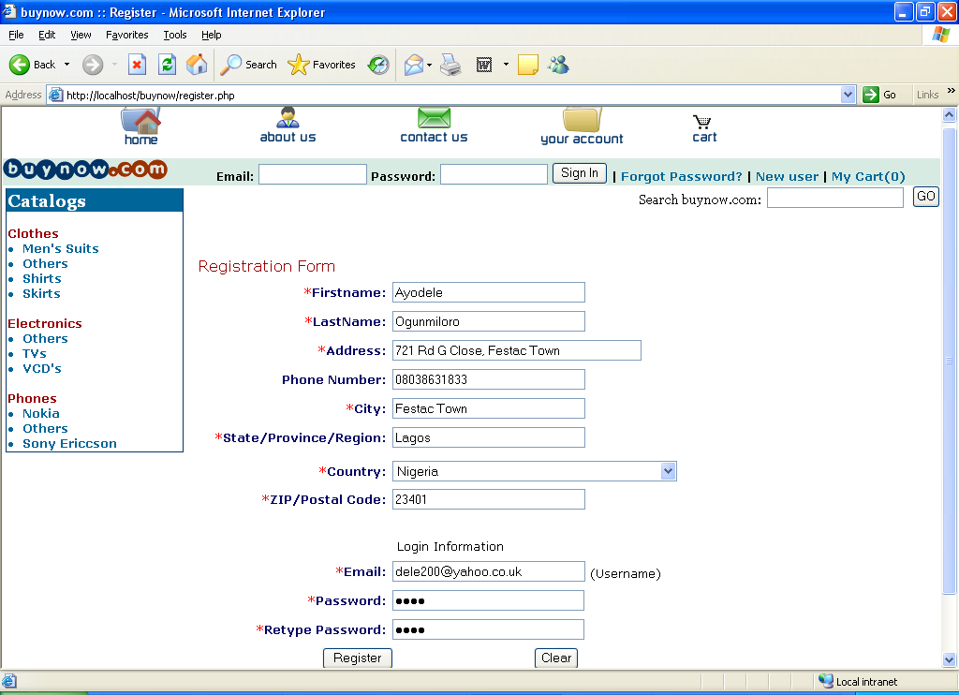
Registration Page

6 Conclusion
This work was carried out with the view of creating an enabling environment for the successful implementation of e-shopping system for SMEs in developing countries. The following areas were has been successfully implemented: New users can be registered; Existing users can login and check their account status, Users can buy products online from our shopping cart application, Users can view a complete list of products available on the shopping cart site, Users can search for products online, Users should be able to search the entire database for keywords, Users can choose and add products to their cart, and decide later whether they would like to buy the selected products, Users can change the quantities of the items or delete items from their cart, before checking out, Users can view the status of products they have ordered, Large number of users can use the application simultaneously. Majority of the specific problems facing developing nations in terms of use of e-shops have been addressed.

Reference
[1]Bah M., Cissé S., Diyamett B., Diallo G., Lerise F.,Okali D., Okpara E., Olawoye J. and
Tacoli C. Changing rural–urban linkages in Mali, Nigeria and Tanzania Environment&Urbanization Vol 15 No 1 April 2003 pp. 13-24.
[2]Beyene A. (2002) Enchaning the competitiveness and productivity of Small and Medium Scale Enterprises (SMEs) in Africa: An Analysis of Differential Roles of National Government Through Improved Support services. African Development vol. XXVII No 3 pp130-156.
[3]Kalakota, R. and Whinston, A.B. (1997), Electronic Commerce: A Manager’s Guide (Reading, MA: Addison-Wesley, 1997).
[4]Powell, T.A. (2002), Web Design: The Complete Reference Second Edition, McGraw-Hill Companies, Inc, USA.
[5]Schneider, G. P. (2002) E-Commerce, Massachusetts:Course Technology-Thomson Learning, Inc., Canada.
[6]Solanki, et al (2001), A Wide Spectrum Language for Designing Web Services, Software Technology Research Laboratory, Leicester, UK.
[7]Udechukwu, F.N. (2003), Survey of Small and Medium Scale Industries and their Potentials in Nigeria. A Seminar on Small and Medium Industries Equity Investments Scheme (SMIEIS) a Publication of CBN Training Centre, Lagos, Central Bank of Nigeria.
[8]Turban, E., King, D., Lee, J., and Viehland, D. (2004) Electronic Commerce: A Managerial Perspective, New Jersey: Pearson Prentice Hall..
[9]Ruzzier M., Hisrich R.B. and Antoncic B (2006) SME Internalization Research: Past, Present, and Future. Journal of Small Business and Enterprise Development 13(4):476-497.
[10] Pare D. J. (2003) Does this site delivers? B2B E-Commerce Services to Developing Countries. Information Society 19:123-134.
[11] Wong Poh-kam (2003) Global and National Factors Affecting Diffusion of E-commerce in Singapore. Information Society 19:19-32.
[12] Molla A. and Heeks R. (2007) Exploring E-Commerce Businesses in developing country. Information Society 23:95-108.
[13] Jen-Her W. and Tzyh-Lih H (2008) Developing E-Business Dynamic Capabilities: an Analysis of E-Commerce Innovation from I-, M-, to U-Commerce. Journal of Organizational Computing and Electronic Commerce 18: 95-111.
[14] Kapurubandara M. and Lawson R. (2008) Availability of E-Commerce Support for SMes in Developing Countries. The International Journal of Advances in ICT for Emerging Regions 01(01): 3-11.

