Abstract — This paper presents a ship simulation system for maritime education which allows simulating ship handling under complicated environmental conditions and threat scenarios. This system simulates real-time six degrees of freedom ship motions (pitch, heave, roll, surge, sway, and yaw) under user interactions and environmental conditions. Today there are proprietary applications for predict real-time six degrees of freedom ship motions. However according to open literature it is difficult to find algorithms for predict real-time six degrees of freedom ship motions. We develop our own algorithms for predict real-time six degrees of freedom ship motions
A Ship Simulation System
for Maritime Education
Damitha Sandaruwan, Nihal Kodikara, Chamath Keppitiyagama and Rexy Rosa

By using this simulation system trainer can demonstrates ship motions, maneuvering tactics and assign particular mission to trainees and evaluate their performance. Trainees can use the simulation system to study at their own pace. These learning and teaching scenarios enable more productive and collaborative learning and teaching environment. Implementation and operational cost of the ship simulation system is a fraction of the conventional training involving real ships. Consequently this ship simulation system reduces the total cost of training and increases the quality of training.

INTRODUCTION
Ship simulations have been used for naval training, ship hull designing, simulating military scenes and entertainment activities such as computer games. Today ship simulations have become an essential tool in maritime education. Ship simulators are use to develop ship handling skills and theoretical understanding of ship motions in naval training.

A major component of the conventional ship maneuvering training is done in real sea environment with real ships. Therefore the total cost of training is extremely high. However, it is not possible to create real scenarios such as terror attacks and rapid environmental changes for training purposes. Ships have six degrees of freedom in ship motion as shown in figure 1 [1]. Maritime lectures in a conventional classroom can only explain ship’s motions one by one, but those motions are occurred simultaneously. Consequently it is not easy to understand that phenomena. However ship simulation system can be used to study these motions in isolation.
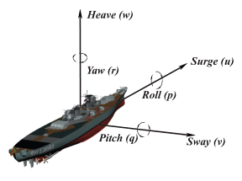
Figure 1: Six degrees of freedom ship motions
There are many commercial ship simulation systems with six degrees of freedom such as Transas and Oceaniccorp [2] [3]. These commercial ship Simulators provide versatile and realistic ship simulation for maritime teaching, learning, assessment and research. However, these systems are extremely expensive, too complicated and proprietary. There is no ship simulation system for marine education available under an open source license, but there are ship motion prediction systems under open source licenses. However, they are not appropriate for learning and training purposes.

Ship maneuvering tactics have to be changed frequently and those tactics depend on various factors such as geographical location, nature of the vessel and environment conditions. However fundamental navigation and maneuvering strategies remains same consequently development of virtual learning and teaching scenarios for maritime education is essential.

Related Work
There are many real-time and none real-time ship motion prediction systems proposed by various researchers and institutes. However it is difficult to find sophisticated six degrees of freedom real-time ship motion prediction systems under an open source license.
Gatis Barauskis et al. [4] proposed a ship simulation system with three degrees of freedom (surge, sway and yaw motions) based on the Nomoto steering equation. Ueng et al. [5] proposed a ship simulation system and they predicted surge, sway, yaw heave, pitch and roll motions based on Newton’s laws, fluid dynamics and other basic physics. However, less attention had been given to added mass/excess drag force due to combined yaw and sway motions and ship’s orientation in horizontal plane with respect to the ocean wave. Sandaruwan et al. [6] proposed a ship model based on Nomoto steering equation, Newton’s laws, fluid dynamics and other basic physics in order to perform more productive and efficient ship motion predictions.
We also note that virtual learning and teaching scenarios for maritime education are not available under an open source license. There are such learning scenarios bundled with commercial ship simulation systems such as “Transas-PISCES2,PISCES” [7].

Implementation of the Simulation system

Overview of the Integrated Simulation System

The simulation system consists of Trainer station, Trainee station, Navigational information display system, cylindrical tiled display system, computational ship model and a database as illustrated in figure 2.

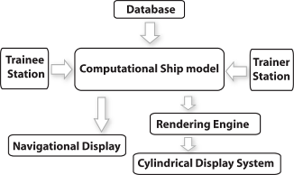

Figure 2: Integrated Simulation System

The trainer can select vessel with predefined physical and mechanical properties and he can select geographical location environmental conditions and threat scenarios where the trainee can essentially be trained. Navigational aids and other necessary indicators are generated and displayed in several display panels. Virtual marine scenes with own ship, moving or fixed targets, cultural objects and environmental effects projected on to five computer screens as shown in figure 3. This real-time vision system covers more than 270 field of view from which under trainee will have the ability to maneuver the ship.

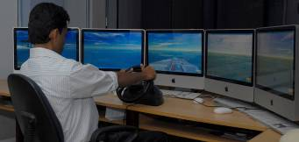

Figure 3: Maneuvering a simulated ship

Computational Ship Model

Computational ship models have been used in ship simulators for naval training, ship hull designing, simulates military science and entertainment activities such as computer games. There are many ship simulation systems with three degrees of freedom and four degrees of freedom [4], but it is difficult to find ship simulation systems with six degrees of freedom [5]. There are commercial ship simulation systems with six degrees of freedom such as Transas simulation systems [2]. These systems are extremely expensive, too complicated and proprietary.

Ship motions
The motion of a floating rigid body can be specified by Newton’s laws, fluid dynamics and other basic physics, but the motion of a floating rigid body in ocean surface is extremely complicated and difficult to predict. All six possible degrees of freedom (6DOF) in a motion of a ship can be illustrated in Figure 1. Surge, heave, and sway are translational motions. Roll, yaw, and pitch are rotational motions [1, 8].
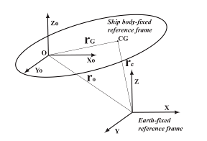
Figure 4: Reference frames and coordinate systems
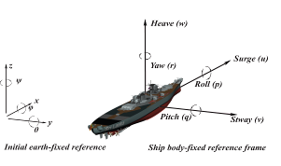
Figure 5: Reference frames and coordinate systems
Following assumptions were made in order to simplify the mathematical ship model for real-time challenges.
- The pitch, heave and roll motions are caused by sea waves. Surge, sway, and yaw motions are induced by internal and external forces such as rudders, propellers and environment conditions such as wind and see currents.
- Figure 4 and 5 illustrate the initial earth-fixed reference frame with [x y z] ^{T} coordinate system and the ship body-fixed reference frame with [x_{o} y_{o} z_{o}] ^{T} coordinate system. Ship body-fixed axes coincide with the principal axes of inertia. Origin of the ship body-fixed frame coincide with the center of gravity of the ship ( r_{G =} [0 0 0 ] ^{T} ) [9].
- The ship is rigid and impossible to deform. The shape of the ship is identical to a cubical.
- The sea waves consist of sinusoidal waves and waves can apply force and moments (Torque) on the ship. However ship cannot influence the wave. The variation of the sea surface is less than or equal to beaufort’s sea state 8 [10].

The magnitudes of the position, orientation, forces, moments, liner velocities and angular velocities are respectively denoted by [x y z] ^{T}, [ψ θ φ] ^{T}, [X Y Z] ^{T}, [K M N] ^{T}, [u v w] ^{T} and [p q r] ^{T} as shown by Table1. The position-orientation vector in the XY plane is expressed as $η$ = [x y ψ] ^{T} and the linear-angular velocity vector is expressed as$v$= [u v r] ^{T}. The rate change of Position-orientation vector is expressed as$\overset{˙}{η}=R(ψ)v$ [11] where $R(ψ)=\left[\begin{matrix}\text{Cos}ψ & −\text{Sin}ψ & 0 \\ \text{Sin}ψ & \text{Cos}ψ & 0 \\ 0 & 0 & 1\end{matrix}\right]$. (1)

Degrees  of freedom | Forces  Moments | Linear/Angular Velocities | Positions  Euler Angles
Surge | X | u | x
Sway | Y | v | y
Heave | Z | w | z
Yaw | N | r | ψ
Pitch | M | q | θ
Roll | K | p | φ
Table 1: six possible degrees of freedom ship motion [1]
Wave Model
We use multivariable ocean wave model introduced by Ching-Tang [8] to model the sea surface and determine the height field of the sea surface. In that model,
$h(\text{xyt})=\sum_{i=1}^{n}{A_{i}{\text{sink}}_{i}[({\text{xcosθ}}_{i}}+{\text{ysinθ}}_{i})−ω_{i}t+φ_{i}]$. (2)
Above function represents a water surface height on the Z axis direction. A is the wave amplitude, k is the wave number where this number is defined as 2π /λ by the wave length λ. ω is the pulsation which is defined as the 2πf by the frequency f. A , k , and f are time (t) dependent variables. θ is the angle between X axis and the direction of the wave. φ is the initial phase which can be selected randomly between 0 - 2π.

Related Work
There are mathematical models to predict ship motions based on the strip theory [12], Kalman filter technique [13]. However, we cannot use the above mentioned prediction methods for real time ship motion prediction because they may take hours to produce an accurate prediction, They need deep knowledge of the ship data, focused only on calm sea surfaces or over simplified. Predictions of ship motions due to ocean waves are extremely difficult to predict accurately for real time applications. There are some commercial products but they are extremely expensive, too complex and proprietary.

Surge Motion
The surge motion of a ship is described by a simplification of the non-linear speed equation as follows [9, 14].
$M\overset{˙}{u}=T_{e}−X_{u\left|u\right|}u\left|u\right|−(M+X_{\text{vr}})\text{vr}$ (3)
In equation (3) M and $T_{e}$ respectively denote the ship’s mass and single driving force (effective propeller thrust) that is transmitted from the ship engine by her propellers. The two terms $X_{u\left|u\right|}u\left|u\right|$ and can be regarded as damping forces, which depend on the instantaneous dynamics of the vessel. represents excess drag force due to combined yaw and sway motion. correspond to the quadratic resistance force at the forward speed u. When the ship traveling a straight course and at a constant speed u, and. Then, if we know T_{e} and u then it is possible to calculate the. The force of the propeller is related to its revolution speed n and the diameter D and the thrust coefficient K_{t} and it is given by T_{e} = K_{t}n²D⁴ [15]. X_{vr} = 0.33 M [11].

Yaw Motion
The yaw motion of the ship is described by using the first order Nomoto model and the transfer function from rudder angle δ r is equivalent to the time domain differential equation as follows [9, 16].
$τ\overset{˙}{r}+r=Kδ$ (4)
K is the steady-state gain of the system and is the time constant. K and can be calculated by using Maneuver Tests [6]. This model behaves more accurately within the linear region of a ship’s steering function up to rudder angles of approximately ten degrees. [9, 16]

Sway Motion
Sway motion is considered based on the transfer function model with constant parameters.It is equivalent to the time domain differential equation given below [9, 14].
$τ_{v}\overset{˙}{v}+v=K_{v}(τ\overset{˙}{r}+r)$ (5)
K_{v} is the steady-state gain in sway and Kv is the time constant in sway. The time constant and the steady state constant have been assumed to be and = 0.3[4, 9]

Motions Caused by Sea Waves
By solving the equation (1),(3),(4) and (5) we can compute the ship’s position orientation vector in the XY-horizontal plane with respect to time. That means we can calculate x, y, u, v and ψ. Then according to Archimedes’ principle[17] we assume the translational motion (heave) and rotational motions (pitch, and roll) are generated by the swellness of water under the ship. It can be calculated by using the height variation of the sea surface. We assume that the shape of the ship is cubical as illustrated in Figure 6 and the ship body is vertically projected onto the sea surface to get the l×w bounding box. It is divided in to 1m×1m cells for mathematical convenience as illustrated in Figure 7. We evaluate the height fields at center points of each 1m×1m cells and we assume the ship is not actually presented when the height field is calculated. We can use Ching-Tang’s wave model [8] to calculate height fields. We assume that the projected bounding box and its points move with the ship. Then, any time we can calculate height fields according to ship’s orientation and the wave propagation. We can obtain forces and moments to generate the heave, pitch and roll motions by calculating the height fields for overall bounding box, calculating difference of height fields between the front and rear halves of the bounding box and calculating difference of height field between the Port and starboard halves of the bounding box respectively.
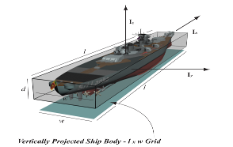
Figure 6: The shape of the ship is identical to a cubical
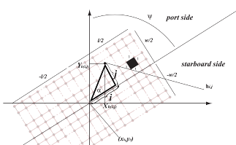
Figure 7: Vertically projected ship body (l × w grid)
Heave Motion
First we calculate the vertical variation (height fields) of each 1m×1m cells. If the some of height fields is not zero the swell of the sea surface generate the force to raise up or pull down the ship. The sum of height fields is H_{a} and h_{i,j} denote the height field of (i,j) point with respect to vertically projected ship body ( l × w grid).When we know the ship’s position in XY plane (x_{o,}y_{o}) and the heading (Euler Angle) with respect to positive X-axis (ψ), we can compute the earth fixed coordinate (x_{hi,j}, y_{hi,j}) for each and every ship fixed coordinate _{hi},j in vertically projected ship body (l× w grid) as illustrated in figure 4. The height field of (i,j) point in the vertically projected ship body is equivalent to the height field of $(X_{h_{(\text{i,j})}}{\text{,Y}}_{h_{(\text{i,j})}})$ point in earth fixed coordinate system. Height fields of earth fixed coordinates can be calculated by using Ching-Tang’s wave model [8]. i.e. $h(\text{i,j,t})=h(X_{h_{(\text{i,j})}}{\text{,Y}}_{h_{(\text{i,j})}}\text{,t})$,$X_{h_{(i,j)}}=\sqrt{i^{2}+j^{2}}\text{Sin}(ψ−α)$, $Y_{h_{(i,j)}}=\sqrt{i^{2}+j^{2}}c\text{os }(ψ−α)$ and $α={\text{tan}}^{−1}ji$.
The sum of height fields in vertically projected ship body (l × w grid)$H_{a}=\sum_{i=\frac{−l}{2}}^{\frac{l}{2}}{\sum_{j=\frac{−w}{2}}^{\frac{w}{2}}{h_{i,j}}}$.
The force for heave motion is can be calculated by multiplying the sum of the height fields and Sea water density ₍Sw). The net force for heave motion ₍Fh) can be calculated by subtracting the resistance force ₍Rh). $K_{{}_{h}}$, M,$\overset{˙}{w}$,$w$ denote the resistance coefficient for heave motion, Mass of the ship, heave acceleration and heave velocity [16]. The equations are listed below.
$R_{h}=K_{h}M{\left|w\right|}^{2}$ $F_{h}=H_{a}S_{w}−R_{h}$ $\overset{˙}{w}=F_{h}M$ $\overset{˙}{w}Δt=Δw$

Pitch Motion
Here we assume that pitch is determined by the difference of height field between front and rear halves of the ship. H_{p} is the height field deference between the front and rear halves of the ship.
$$H_{p}=\sum_{i=\frac{−l}{2}}^{\frac{l}{2}}{\sum_{j=\frac{−w}{2}}^{\frac{w}{2}}{h_{i,j}}}\frac{i}{\left|i\right|}$$
By using Ching-Tang’s wave model [8], h_{i,j} can be calculated. Then the net force for pitch (F_{p}), pitch angular acceleration ($\overset{˙}{q}$) and pitch angular velocity (q) is determined as follows:
$R_{p}=K_{p}I_{p}q$ $F_{p}=H_{p}S_{w}−R_{p}$ $\overset{˙}{q}=F_{p}I_{p}$ $\overset{˙}{q}Δt=Δq$
S_{w},K_{p},R_{p},I_{p} denote the sea water density, resistance coefficient for pitch motion, resistance force against pitch motion and the ship’s moment of inertia along Y-axis respectively. For mathematical convenience we assumed the shape of the ship is cubical as shown in Fig 03 then$I_{p}=\frac{1}{\text{12}}M(l^{2}+d^{2})$.
Roll Motion
Here we assume that roll is determined by the difference of height field between the port side and starboard side halves of the ship. H_{r} is the height field deference between the port side and starboard side halves of the ship.
$$H_{r}=\sum_{i=\frac{−l}{2}}^{\frac{l}{2}}{\sum_{j=\frac{−w}{2}}^{\frac{w}{2}}{h_{i,j}}}\frac{j}{\left|j\right|}$$
Then as we did in the pitch motion calculations we can calculate net force for roll motion, roll angular acceleration and roll angular velocity.

Overview of the computational ship model
The system consists of two major stages. First stage is to compute ship’s position and orientation in XY plane by using ship’s physical data, user defined dynamic properties (Rudder, Engine RPM) and resistance forces due to motion. The second stage is compute heave, pitch and roll motion by using the out puts of the first stage and additionally considering the ocean wave model as illustrated in figure 8. In this system, we use constraints, coefficients and parameters like K, $τ$, K_{p}, K_{h} sometime we can evaluate them or we have to figure out reasonable values for them.

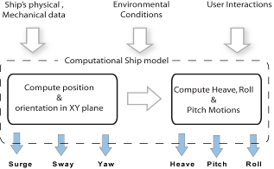

Figure 8: Computational Ship model

Our ship motion prediction algorithms are more suitable for ocean surface vehicles which have approximately box type geometric formations. Our real-time ship motion prediction algorithms were validated with respect to benchmark sea trials of the “Esso Ossaka Tanker”[18] and the “ShipMo3D”[19]commercial ship motion prediction system.
Esso Osaka is a tanker with approximately box type geometric formation as shown in the figure 9 and “ShipMo3D” is an object-oriented library with associated user applications for predicting ship motions. “ShipMo3D” was validated with respect to benchmark sea trials of the “Esso Osaka Tanker”. We consider the same scenario and modeled “Esso Osaka” by using our algorithms. We used MATLAB [20] simulink and 2.66GHz Intel Core 2 Duo iMac to run our computational ship model. The outcome shows satisfactory results as shown in the figure 10.
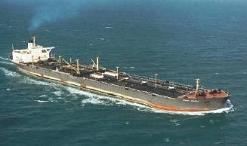
Figure 9: Esso Ossaka Tanker.
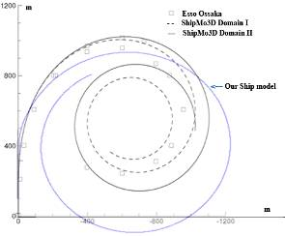
Figure 10: Validation with respect to benchmark “Esso Ossaka” sea trials

Panoramic Vision System
Panoramic images and videos are regularly used in various virtual reality applications such as autonomous navigation and virtual walkthroughs. These navigation systems can be categorized as real-time and offline based on the amount of time taken to render the panorama after the virtual scenery has been captured by the virtual camera. On the other hand we can categorize these navigation systems according to the degrees of freedom. According to open literature it is difficult to find real-time six degrees of freedom autonomous navigation system with 300⁰ field of view. However we were able to build this kind of panoramic vision system.

This vision system is based on the client-server architecture. The server computer sends the navigational instructions (latitude, longitude, altitude, roll, pitch, and yaw) to the six the client computers as shown in the figure 11.
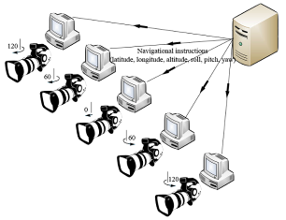
Figure 11: Structure of the vision system.
In each client computer the same virtual environment is loaded and the position and the orientation values received by a parental node. Each virtual camera inherits it’s position and orientation from the parental node while maintaining 60 degrees with respect to adjacent virtual cameras as shown in the figure 12.
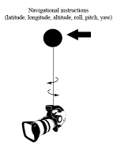
Figure 12: Virtual camera and it’s parental node.
To create tile 300°field of view (FOV) each virtual camera occupies 60⁰ angle of view [21]. Navigational instructions (latitude, longitude, altitude, roll, pitch, yaw) are send to virtual cameras from the master computer over the network.
We develop a method for synchronize each and every virtual camera. The sever computer send data set containing latitude, longitude, altitude, roll, pitch, yaw simultaneously to each client computer through net work. Each and every client PC should pace the virtual camera according to the given position and orientation and render the scenery. After completing the rendering process each client machine should send a message to sever computer then the sever computer. Then the sever computer send the next navigational instruction data set after acquiring all six massages from the client computers. This synchronization mechanism reduces the frame rate a little but the above mentioned 2.66GHz Intel Core 2 Duo iMacs with NVIDIA GeForce 9400M graphic cards were able to maintain more than 25 Frames per second with complex scenery.

Database
In this ship simulation system we use our own computational ship models based on our algorithms and constrain so that we can incorporate any computational ship model to our database which satisfy our algorithms and constrains. We have developed several six degrees of freedom computational ship models such as benchmark tanker “Esso Ossaka” and offshore patrol vessel quite identical to “Jayasagara” class which has been locally built by the Sri Lankan dockyard [22]. We incorporated real world geographical sceneries with cultural objects, moving/ fixed targets, several environmental conditions and wide range of visibility and illumination effects such as daytime, dusk and night were incorporated into our database.

We modeled a Sri Lankan harbor and incorporated into to our data base. We used British admiralty charts “Galle harbor and approaches” as shown in the figure 13 [23] and Google earth [24] images shown in the figure 14 for the 3D modeling.

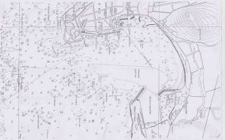

Figure 13: “Galle harbor” navigational map
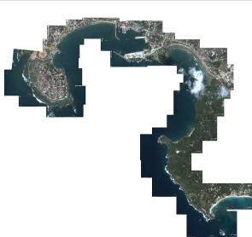
Figure 14: Top view of the selected harbor.
Subsequently the shore line was finalized and sequence of digital pictures was taken from sea while keeping the same distance from the shore line.
Same process was repeated several times to get deferent image sequences with deferent distances from the shore line. Various moving and fixed targets and cultural objects were observed in the sea around the selected harbor. The relative sizes of the observed object were recorded with respect to a selected earth fixed object and digital pictures were taken from different distances.
We used 3D studio max to create mesh models. All naval vessels, moving or fixed targets, and cultural objects, scenes of navigation areas were modeled using 3D studio max[25] .When were modeling the navigation areas and the shore line major objects were modeled with polygonal meshes and the other objects were placed by using the billboards. Throughout this 3D modeling we used appropriate textures to model more realistic scenery. Most of the time we captured the real texture from the digital camera and enhanced by image editing software. Several times we used standard materials from the 3D studio max library. We used OgreMax Scene Exporter to export the modeled scenery from 3D studio max to Ogre 3D. The OgreMax Scene Exporter [26] is a 3DS Max plugin that exports 3DS Max scenes to OgreMax scene files. Finally the virtually created environment is compared with the real environment. The outcome is quite satisfactory level as shown in the figure 15 and figure 16.
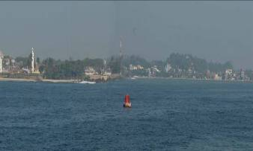
Figure 15: Real harbor environment

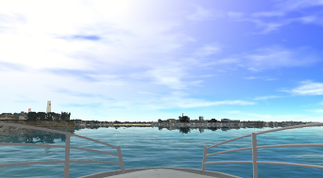

Figure 16: Virtually created harbor environment

Development of immersive environment

The immersive environment is composed of 4 standard game PCs - 3 (clients and a server) and multi projector seamless tiled display system. It was constructed using three multimedia projectors with 2500 ANSI lumens. This large polygonal screen projected realistic visuals with wide field of view and a real scale bridge was constructed and placed as shown in the figure 17.This brings a sense of seriousness and realism to the users perception hence this is strengthening the ecological validity of the environment.

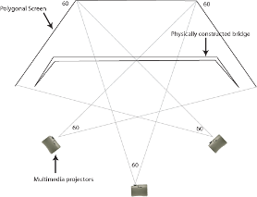
Figure 17: Bridge and projector arrangement.
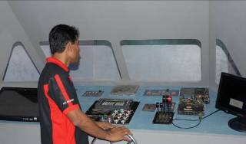
Figure 18: Physically built ship bridge
Discarded real equipments were integrated in to the bridge. In this case real throttle and wheel were interfaced to provide a more realistic virtual environment and a strong sense of immersion as shown in the figure 18. This perception enhanced virtual environment was exhibited in several national and international level exhibitions as shown in figure 19. Large number of people including naval experts, sailors, Navy officers, national and international researchers, game lovers and general public used this immersive environment.

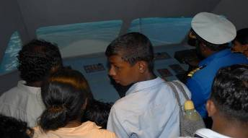
Figure 19: Virtual environment in an exhibition

Teaching and Learning Scenario
There are three kinds of learning and training scenarios where the simulator can be used.

- In class teaching of theoretical aspects of navigation and ship motion.
- Train trainees for particular mission and evaluate their performance.
- Self learning.

In marine education theoretical understanding of ship motions is essential. Variety of phenomena occur simultaneously in short time duration, including drift, turning, speed reduction, drift angle, heading. The trainer can use the simulation system and demonstrate those ship motions in real-time. Trainer can select a ship, geographical scene of the navigation area, cultural objects, moving/ fixed targets, environmental conditions. He can demonstrate ship maneuvering tactics and the use of the navigational display consisting of radar, sonar, 2D map, engine RPM indicator and the rudder angle indicator. The trainer can also demonstrate how to deal with various threat scenarios. Then trainer can define various missions with different difficulty levels and let under trainee to gain ship maneuvering skills. While the trainee is maneuvering the ship the trainer can change difficulty levels and threat scenarios. After several training sessions the trainer can give specific mission and evaluate the trainee’s performance. Trainees can use the simulation system and select ship, geographical scenery, define his own difficulty levels and study at their own pace. These learning scenarios enhance the teaching and learning experience.

Sample learning activity
A basic learning activity is developed with the help of the navel experts from the Sri Lanka Navy according to their fundamental navigation lessons with real ship.

Lesson Title: Basic Navigation
Simulated Ship: offshore patrol vessel ( Ship’s length, beam, draft, mass and maximum effective thrust are respectively 48 m, 8.6 m, 2.2 m, 35.6 x 10⁴ Kg and 15.0 x 10⁴ N)
Sea State: Beaufort Sea state 3
Present geographical location is given
Mission: Cast off the ship from the present location and proceed to given location and anchorage within given time frame.

Trainee has to use the simulation system. Geographical map of the navigation area as shown in Figure 20 and parallel ruler are provided. Several learning activities were carried out with navel experts to experiment our simulation system and further identify learning and teaching requirements.

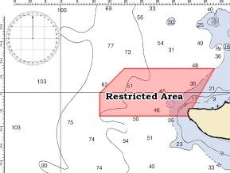
Figure 20: Geographical map of the navigation area

Future Work
Surge, sway and yaw motions of current computational ship model were validated with against the benchmarked ship trials. However in order to validate the roll, pitch and heave motions we have to perform experiments under various conditions with respect to leading industry product or a real world scenario. We have to further develop the mathematical ship model for simulate various kind of modern ships with multiple propellers.
Seamless cylindrical tiled display system should be developed to for further enhance the trainee’s perception. Image stitching and blending algorithms [27] have to be used to get the desired output which is going to be projected on a semi cylindrical projection screen by using the multimedia projectors. Then the trainee can get a more immersive maritime experience. In order to use this simulation system in a wide range of teaching and learning scenarios we have to incorporate more naval vessels, moving or fixed targets, cultural objects , scenes of navigation areas, various environmental effects and conditions to the existing database.
We have to conduct experiments with navel experts to further identify the trainee’s and trainer’s requirements. Consequently various training scenarios have to be designed in order to develop a more productive and efficient virtual learning and training environment. Development of a learning Management System that could monitor trainee, trainer and training activities is essential.

Conclusion
Experience gained through this kind of ship simulation system enables students to understand the dynamic mechanism behind the ship motion. It is possible to create virtual scenarios such as motion of enemy ships and rapid environmental changes for training purposes which are not possible in conventional ship maneuvering training done in real sea environment with real ships. Naval trainers can use this system for in class teaching of theoretical aspects of navigation and ship motion. In addition to that trainers can train trainees for particular mission and evaluate their performance. Trainee can use the system and define various tactical scenarios within different difficulty levels so that they can learn at their own pace. Implementation and running cost of this ship simulation system is minimal in comparison to the conventional training involving real ships. Consequently this ship simulation system reduces the total cost of training and increases the quality of training.

Experimental results show that the proposed framework is very effective for a virtual maritime learning and training purposes and it is scalable and comparable to industry standard full scale simulators with perception enhanced cylindrical vision system. We plan to make this ship simulation system available under an open source license so that anyone can customize or further develop it according to their requirements.

Acknowledgment
Our thanks to Department of electrical and electronic, Sri Lanka navy and the National e-learning center, Sri Lanka for their collaborative support.

References
- Nomenclature for Treating the Motion of a Submerged Body Through a Fluid. Technical and Research (1950), Bulletin No 1-5, The Society of Naval Architects and Marine Engineers, New York.
- Commercial ship simulations systems developed by Transas [Online]. Available: http://www.transas.com/
- Commercial ship simulations systems developed by Oceanic Consulting Corporation [Online]. Available: http://www.oceaniccorp.com/
- G. Barauskis and P. Friis-Hansen “Fast Time Ship Simulator”. AIS Data and Risk Assessment, Deliverable B2.1, Version No 002 .Safety at Sea conference -2007
- S. Ueng, D. Lin and C. Liu (2008) – “A ship motion simulation system”Virtual Reality- Volume 12, Issue 1, pringer-Verlag London, UK
- D. Sandaruwan, N. Kodikara, C. Keppitiyagama, and R. Rosa, (2009) “Real-time Ship Motion Prediction System”. Computer Games Multimedia and Allied Technology 09 Singapore.
- Commercial teaching materials developed by Transas [Online]. Available: http://www.transas.com/products/simulators/sim_products/pisces/
- Ching-Tang Chou and Li-Chen (2007) “Ship on Real-time Rendering Dynamic Ocean Applied in 6-DOF Platform Motion Simulator CACS International Conference”, Taichun, Taiwan
- Thor I Fossen (1994) “Guidance and Control of Ocean Vehicles” ISBN 0 471 94113 1, Jhone Wiley & Sons, Chichester-New York-Brisbane-toronto-singapore
- J. M. J. Journee, and J. Pinkster, “ Introduction in Ship Hydromechanics”. Delft University of Technology, Netherlands, 2002
- Tristan Perezt and Mogens Blanket “Mathematical Modeling for Control Applications”
- Technical Report, University of Newcastle, Australia / Technical University of Denmark Korvin-Kroukovsky BV, Jacobs WR (1957) “Pitching and heaving motions of a ship in regular waves”The Society of Naval Architects and Marine Engineers, New York
- Triantafyllou MS, Bodson M, Athans M (1983). “Real time estimation of ship motions using Kalman filtering techniques”.IEEE Journal of Oceanic Engineering, vol. oe-8
- Blanke M (1981) “Ship Population Losses Related to Automatic Steering and Prime Mover Control”Technical University of Denmark
- Rawson KJ, Tupper EC (2001) “Basic Ship Theory” ISBN 0750653965, 9780750653961, Butterworth-Heinemann
- Nomoto, Taguchi, Honda and Hirano (1956) “Steering Qualities of ships”.Department of Naval Architecture, Osaka University.

- Y. Nakayama, and r. Boucher, “ Introduction to Fluid Mechanics”. ISBN 0340676493, 9780340676493, Butterworth-Heinemann, 1998
- Characteristics of Esso Ossaka Ship [Online]. Available: http://www.aukevisser.nl/inter/id427.htm
- K. Mc Taggart, “ Simulation of Hydrodynamic Forcess and Motions for a Freely Maneuvering Ship in a Seaway”. Defence R & D Canada- Atlantic, 2005
- The MathWorks Matlab Documentations [Online]. Available: http://www.mathworks.com
- G. Junker, “ Pro Ogre 3D Programming”. ISBN-13-978-1-59059-710-1,Springer-Verlag, 2006.
- Characteristics of Jayasagara Ship [Online]. Available: http://en.wikipedia.org/wiki/Jayasagara_class_patrol_craft
- British admiralty charts [Online]. Available: http://www.mdnautical.com/britishadmiraltycharts.htm
- Satelight Image Source [Online]. Available: http://earth.google.com
- The Autodesk 3D Studio Max Documentations [Online]. Available: http://usa.autodesk.com
- The Ogremax Documentations [Online]. Available: http://www.ogremax.com
- V. Rankov, J. Rosalind, J. Locke, J. Richard, P. R. Barber and B. Vojnovic, “An algorithm for image stitching and blending”. SPIE vol. 5701, 2005.

Damitha Sandaruwan: He has obtained his B.Sc from University Of Colombo Faculty Of Science. He is currently doing his M.Phil research and working as a media officer at the University of Colombo School Of Computing (UCSC). He has research interests in real-time simulations, Mathematical modeling and 3D graphics.

Nihal Kodikara: He is a Senior Lecturer attached to the University of Colombo School Of Computing. He has obtained his B.Sc. from the University of Colombo and M.Sc and Ph.D. in Computer Science from the University of Manchester, U.K. He is presently the Head of the Department of Information Systems Engineering and the Head of Post graduate Studies at the UCSC. His research interests include Computer Graphics, Computer Vision and e-Goverance.

Rexy Rosa: He is a Senior Lecturer attached to the University Of Colombo Faculty Of Science. He has obtained his B.Sc. from the University of Colombo and M.Sc and Ph.D from the University of Pittsburgh, U.S.A. He is presently the Head of the Department of Physics University of Colombo. His research interests include Gamma Ray Spectroscopy and Physics Education.

Chamath Keppitiyagama: He has obtained his B.Sc from the University of Colombo and M.Sc and Ph.D in Computer Science from the University of British Columbia (UBC) in Vancouver. He is currently working as a Senior Lecturer at the University of Colombo School Of Computing (UCSC). He is one of the coordinators of the Master's program at UCSC. He has research interests in Distributed Computing, Computer Networks, Operating Systems and Sensor Networks.

  Manuscript received March 22, 2010. This research was funded by the National e-Learning center, Sri Lanka and supported by Department of electrical and electronic Sri Lanka navy. Damitha Sandaruwan is with the University of Colombo School of Computing, 35, Reid Avenue, Colombo, Sri Lanka 7;Tel: +94 -11- 2581245/ 7( e-mail: dsr@ucsc.cmb.ac.lk). Nihal Kodikara and Chamath Keppitiyagama are also with the University of Colombo School of Computing,35 ,Reid Avenue ,Colombo 7, Sri Lanka; Tel: +94 -11- 2581245/ 7(e-mail: ndk@ucsc.cmb.ac.lk, Chamath@ucsc.cmb.ac.lk) Rexy Rosa is with the Department of Physics, University of Colombo, Colombo 7, Sri Lanka ;Tel:+94 -11- 2584777 (e-mail: rosa@phys.cmb.ac.lk)

